**Use Cases**

A use case is specified by a particular goal of the user, what the user needs to accomplish, the below points are the use cases of this application listed:

* **Actors**: Chef, Owner, Treasurer, Administrator and Customers
* **Use Case 1: Making Orders**

Actor: Chef

Use case purpose: To prepare orders for customers

Pre-condition: Knowledge of using the application

Post condition: Selecting the appropriate orders to prepare

Limitations: Unable to prepare orders, lack of ingredients

Basic Flow: Once the order is placed on website, the chef will receive the alert for the order. Chef starts preparing the order by selecting the order list form the application on priority basis. Once the order is complete by the chef, he/she will update the status of the order on the system as ‘order completed’.

* **Use Case 2: Oversee the content of the website**

Actor: Owner

Use case purpose: Ensure website functionality and perform software updates

Pre-condition: Knowledge of performing updates and making amendments

Post condition: Maintaining the web application every now and then

Limitations: Unable to download the update due to lack of space or human error

Basic Flow: Owner of the application monitor, assess and reports on the website application. Owner has to ensure the domain registration and hosting are up to date and always available. Owner has the responsibility to check if any content of the website is correct, owner has to change/update the content of the website to maintain customer service. Owner has to come up with new ideas or food offers to make the website look attractive, so the business popularity can increase.

* **Use Case 3: Managing the financial oversight**

Actor: Treasurer

Use case purpose: Ensure website functionality and perform software updates

Pre-condition: Knowledge of maintaining the budget of the business/website

Post condition: Planning the budget of web application every now and then

Limitations: Lack of experience to plan the budget

Basic Flow: To maintain the general financial of the website application, to keep the records of the customers, banking and book keeping. Keep the track of fixed asset and stock in the business.

* **Use Case 4: Administrating/Supervising the business**

Actor: Administrator

Use case purpose: Ensuring/Managing the business day to day activities

Pre-condition: Experience of Administrator

Post condition: Planning daily activities for the business

Limitations: Lack of experience as being administrator

Basic Flow: recruiting, training and supervising the staff, planning menus, ensuring compliance with licensing, hygiene and health and safety legislation/guidelines, overseeing stock levels, ordering supplies and producing staff rotas.

* **Use Case 5: Placing Orders**

Actor: Customers

Use case purpose: To place the food item order online

Pre-condition: Knowledge of using the website and navigation

Post condition: Selecting the appropriate action

Limitations: Unable to order food due to lack of experience

Basic Flow: Customers will visit the website and navigate to the menu page and select the food item they want to order, on selecting the order they can add the item into the cart and increase the quantity as per their wish and once they have completed with orders they can click button place order followed by making secure payment.

Alternative Flow: Customer can order any of the top 10 food item straight away from the home page without visiting the menu page if they want.

* **Use Case 6: Providing online receipt**

Actor: Treasurer

Use case purpose: To provide receipt to the customers online via email

Pre-condition: Knowledge of using application and choosing correct option

Post condition: Selecting appropriate options

Limitations: No receipt provided due to not given email address

Basic Flow: Once the customer has paid the bill of the order, the customer receives an online bill through their email address.

* **Use Case 7: Providing Feedback**

Actor: Customer

Use case purpose: Providing feedback for the business to improve their service

Pre-condition: Knowledge of using the feedback section

Post condition: Providing feed back to the business for better service

Limitations: Unable to provide feedback due to lack of knowledge

Basic Flow: Once the customer has received their order, the customer can visit the website and go to the contact page to fill out the feedback form of which they have received the service. Customer can also give a positive feedback of the food item as appreciation feedback and they can click on submit form.

* **Use Case 8: Requesting for events orders**

Actor: Customer

Use case purpose: Inquiring regarding the bulk orders/event organisation orders

Pre-condition: Knowledge of using the contact us section

Post condition: Selecting appropriate action

Limitations: Unable to provide more information as lake of space/word count

Basic Flow: If the customer wants to place order in bulk or wants to organise an event where he needs to place a bulk of order, the customer can visit the contact page on website and fill out the inquiry form to ask details or to place bulk order for events.

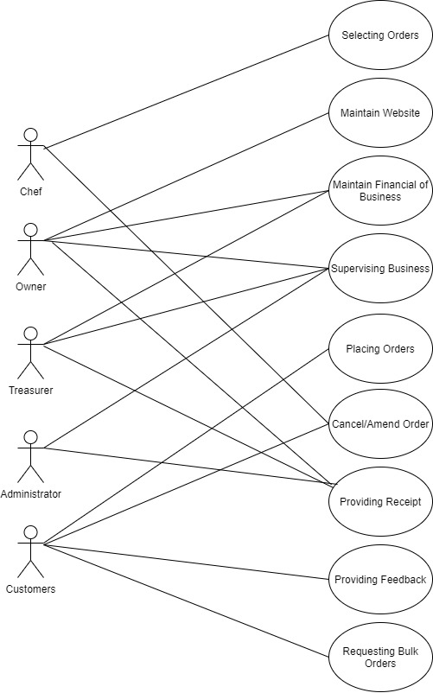

|  |  |
| --- | --- |
| **User Actions** | **System Actions** |
| **Customer**   1. Customer clicks on menu page to view food items. 2. Customer adds the items to the cart and customize them. 3. Customers places the order for food items. 4. Customer cancel/amend the food item order. 5. Customer makes the payment by adding their personal details and card details. 6. Customer provide the feedback to the restaurant by sharing their name and email address. 7. Customer makes an inquiry for bulk orders by sharing his name, email and mobile number.   **Chef**   1. Clicks on the awaiting orders to view customers’ orders. 2. Chef confirms the order and start making the order. 3. Once the order is completed, chef passes the confirmation of order completed. 4. Chef cancels the order of customer on the system’s requirement.   **Owner**   1. Owner checks the website content if there are any mistakes. 2. Ensure the domain and registration of the website. 3. Adds new food item in the menu page of website with description and price.   **Administrator**   1. Passing the customers order to the chef to prepare orders. 2. Passing message to the customers regarding their orders completed. 3. Adds customer customer’s details to the system to keep track of orders. 4. Adds the customer orders and details to generate total bill. 5. Administrator uses the customer email address to provide the receipt via email. | **System**   1. System displays the menu item and other website content to the customers. 2. System accepts the customer order. 3. System calculated the total amount of the bill for customer. 4. System checks the details of customer’s bank card. 5. System makes the contact with the customer’s bank to process payment. 6. System validated the payment of the customers. 7. System checks if the request added by the customer are correct or not. 8. System transfers the bill to customer via their email provided. 9. System makes some changes to the order if requested by the customer. 10. System displays the order to the chef which are requested by the customers. 11. System passes the orders/messages or alert between the chef and administrator. 12. System allows the chef/customer to cancel the order. 13. System passes the confirmation of cancelling the order to customer/chef. 14. System allows the owner of the restaurant to login as admin to ensure the domain and registration of website. 15. System allows to change/edit the content of the website. 16. System displays the tracking of the customer’s order. |

**Use Case 11:** Calculation of the bill

Primary Actor: Administrator

Goal: To calculate the bill for the customer

Other Stakeholders: Administrator

Preconditions: Must select only the food items to calculate their total

Success Condition: To calculate the total bill amount of the food items in order

Main Sequence:

1. Admin will open the menu section in their portal
2. System will display all the menu items with their price
3. Admin will select only the food items as mentioned in customer’s order
4. System calculates the food item price in the background as the admin keeps selecting
5. Admin clicks on the next button
6. System will display the total price for the customer order

**Use Case 12:** Cancelation of order

Primary Actor: Administrator

Goal: To cancel the customer order

Preconditions: Appropriate customer order must be selected to cancel order

Success Condition: To cancel the customer order

Main Sequence:

1. Admin will receive the alert by the customer to cancel the order
2. Admin will open the orders section in their portal
3. System will display the order number and orders placed by customers
4. Admin will check the order number of the customer
5. Admin clicks on cancel order button for the specific order
6. System will display the message ‘order cancelled successfully’